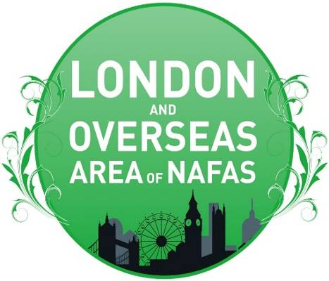 | AREA NEWS  SPRING EDITION 2026  Edited by Pat Laughton  London and Overseas Area of NAFAS  President: Sheila Tasker  Chairman: Martyn Best (Acting Chairman)

ACTING CHAIRMAN REPORT July 2026

Dear Members – My first comment must be to the continued tremendous support that, as Acting Chairman, I have received from Sheila Tasker - President, Angela Woodley -Treasurer and Acting Secretary, Val Best and Pat Dibben, Chair and Vice Chair of JDS&E, along with June Ford - Past President and members of the PAC team (Past Area Chairman).
The Area could not have functioned as well as it has done without their assistance, making up for the short fall in functioning officers.
To this end a notice has now been sent to all clubs, with amended Terms of Reference to hopefully encourage members to apply for the current vacancy of Secretary and in the future, that of a Treasurer.
~
In a joint venture with Home Counties Area, a very successful Multi-Discipline Training and Refresher Day entitled “Refresh and Renew” with Valerie Best, Pat Dibben and Lesley Sturdy was held on 27th May at Canons Hall, Stanmore. A Certificate of Attendance was issued to all participants.
~
We are now halfway through the year, and the Area Management Team have fulfilled their obligation, as promised, to hold Regional Area Councils and the first one is to be held on Thursday 23rd July at Hesdin Hall, 73 Pembroke Road, Ruislip HA4 8NN. Nearest underground station is Ruislip Manor, Metropolitan Line.

Following Area business and after a short lunch break, Jilly Griffin (NAFAS Westminster Coordinator) will give a presentation on flowers at Westminster Abbey. Pat Dibben will arrange a Pedestal Exhibit. A new area demonstrator, Helen Temple, will give examples of her designs.
This being a new venture which we trust will be well supported.
~
On October 6th, a floral demonstration by Internationally Acclaimed Ian Lloyd, entitled “My Italian Life” will be held at New Windmill Hall, St Mary’s Lane, Upminster RM14 2QH.

(The day starts at 11.30 and tea, coffee and lunch are included in the price of the ticket which is £25. We do hope your members will be interested as the hall is just a few minutes from Upminster underground station. Tickets can be purchased (card payments accepted) by contacting:
Angela Woodley at: treasurer@flowerarranginglondon.org.uk mobile: 07973151791)
~
The second regional Area Council will be held on October 24th at St. Francis Church Hall, 68 Ravenswood Avenue, West Wickham, followed by National Speaker and then an International Flower Demonstrator. (details to follow)

Martyn Best, Acting Chairman

Club’s round up

BC Floral Art Society celebrates its 55th Emerald Anniversary

In June, BC Floral Art Society based in Western Canada, celebrated its 55th anniversary by holding a tea party. Members brought designs for the showbench based on this theme, such as pave, miniature and petite designs representing cakes, teapots and plates of food. There was a cake cutting ceremony and floral headpieces were worn. A good time was had by all.

Ann Peters, Treasurer

Ealing FC

Following our AGM last month, we had a very interesting talk by Andrea Bugari on Ethno Botany. I had no idea that so many wildflowers (weeds to me I'm afraid to say) could be eaten. I shall look at them with different eyes from now on.

Upcoming Summer Event



Dates for our Flower Festival 'Cinema in Bloom' Thursday 16th and Friday 17th July Midday to 6pm and Saturday 18th July 10am to 4pm 2026 in St. Barnabas Church. Celebrating 110 years of St. Barnabas Church and Ealing's connections to the film world, in conjunction with Pitshanger Pictures

Estepona FC

In May Estepona welcomed Vivien Withers from Weybridge, Surrey. Vivien is the principal of the family run Cleves Wood Floristry. On 2nd June Estepona held their AGM and made the following announcement:

It is with profound regret that the decision was taken to place Estepona Floral Art Society into permanent recess as of 31st December 2026. The decision was not taken lightly. The reasons are threefold:

It is unsustainable financially to continue. The increased costs of airfares, flowers, transport, meals, and accommodation have made hosting demonstrators no longer viable. We simply do not have the membership support to fundraise to cover these costs.

Our membership has dramatically decreased. Years ago, pre-Covid, pre-Brexit we had around 50 fully paid-up members. This year we have 15 fully paid members, 7 of whom are committee members.
That brings me to the third reason, the committee. Jo Gould, Marilyn Pemberton, Barbara Bassadone and Jan Carter have served on the committee for many years. Liz Vela, Edwina Bennett and I joined more recently. And now all seven of us have other time-consuming personal and family commitments. The committee has been enthusiastic, tireless, energetic and committed to the Society, but this is also no longer sustainable for any of us. However, we do have some brighter news. Moving forward, we have three fantastic NAFAS national demonstrators joining us in September, October and November.

David Thomson, he of the colourful butterfly shirts, rolling Scottish accent and innovative designs is back with us on September 15th.
On October 20th we welcome Jacqui Arnold to Estepona. Jacqui is a two-time RHS Chelsea Gold Medalist and the winner of umpteen floral awards.
Our Christmas demonstration is on November 17th when we are delighted to welcome Nigel Whyles back to Estepona. Nigel’s work has appeared at the RHS Chelsea Flower Show, Westminster Abbey and major flower shows across the UK.

Dawn Short, Chairman

Orpington FAS

A workshop at Orpington FAS recently took place and I chose this particular picture from those sent to me by Margaret Hawkins as I thought the use of fresh mixed with some very creative paper flowers was very effective.  Norma Leslie, Chairman  Margaret writes:  The design was based on the front cover of the Spring Flower Arranger magazine.  Norma Leslie supplied the containers and mechanics, participants were free to bring their own choice of flowers.  Margaret Hawkins, Secretary | 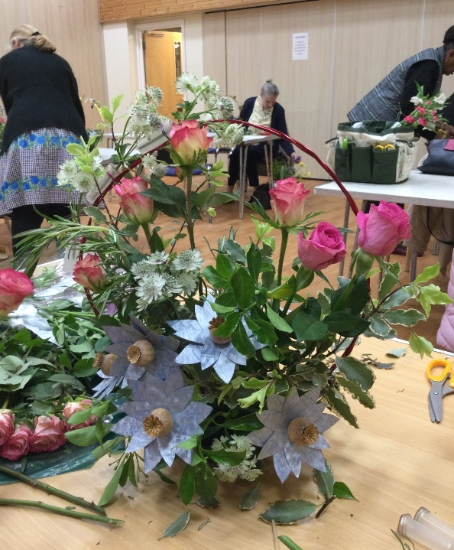

TOTTERIDGE FLORAL ART CLUB – 1966 – 2026

At a house in Mill Hill on 15th February 1966 a group of like-minded people met together for the first committee meeting of Totteridge Floral Art Club. The first Chairman was a man! They had £7.8/10p in the kitty, (old money) so they were planning a luncheon to raise funds! One of our longest serving members, the Late Vera Perry was at that first meeting. Vera went on to represent the Club at L & O area meetings.

Skipping though that old handwritten Minute Book you soon realised that, from the very start, the Club was very active and very successful, in fact, the Club has continued in this way over the years and many of our members are now in their 90’s! But where are the new members? Sadly, this is the problem, there is more choice for the younger people, they lead busy lives, the gym beckons, their children have more active lives, therefore, our membership has dwindled. The 21st century is upon us!
So, reluctantly and with sadness, the Club will close after our demonstration in July. Unless we find at least three or four vigorous ladies (or gentlemen for that matter) to take over!….
Meanwhile, we have our wonderful memories and friendships formed over the years.
Flowers bring pleasure, the Club gave pleasure, we’ve had 60 fabulous years!
Thanks for the memory
TOTTERIDGE FLORAL ART CLUB WE LOVED YOU!

Jenny Gilks/Cornes, President - Totteridge Floral Art Club

Totteridge members wave goodbye……………

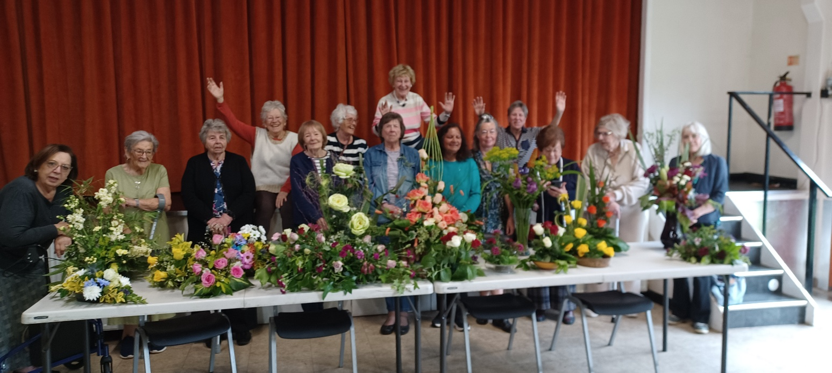

West Wickham FC

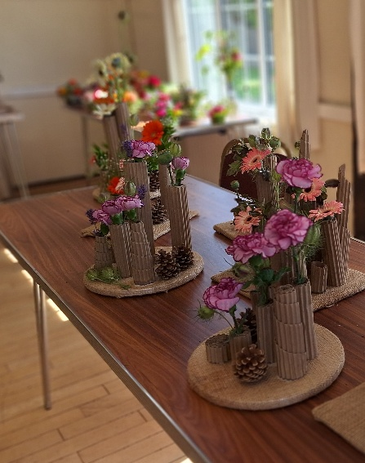 | On 13th June West Wickham held a workshop which was well attended. In the morning Christine Milburn demonstrated an arrangement in a cup and saucer and following lunch Angela Woodley showed the students this rather clever idea of incorporating corrugated cardboard to create a design that allowed students to experiment with shapes and sizes. Must mention that this design had previously been the subject of a workshop at Breakthrough by Robin White but why not spread the idea around!

In May an Area Refresher Day was held by the L&O and Home Counties areas of NAFAS.

The event was well attended and below a member works on her exhibit and the photo of the beautiful design opposite was taken by Helen Evans
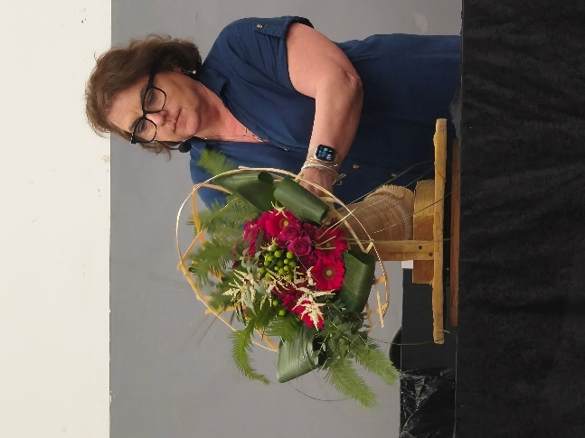 | 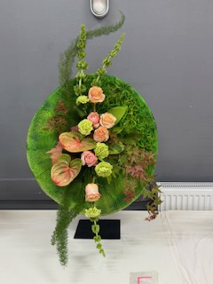

Sian Tribe’s Moment of Fame

Radio 2 "Pitch Your Passion" slot with Romesh Ranganathan

I often listen to radio 2 at the weekends and Pitch your Passion on Romesh Ranganathan’s show on Saturday at 12.15 ish. Two people Pitch their Passions in 45 seconds, and one wins, but you get your passion heard!

About 3 weeks before I was on the Air, I sent a note to the show saying that I wanted to Pitch flower clubs.

The producer came back to me and said could I talk about Flower Arranging instead. So, I duly wrote my script to mention flower clubs and NAFAS.

I was very nervous on the day but got my script read in good time. Obviously, the Football Referee won the pitch, but I got my moment of fame!

Ealing Flower Club taped my efforts on their Instagram page, and many Flowery Friends congratulated me on getting Flower Arranging out there!

Fun with Flowers!

Sian Tribe, Blackheath FC

From across the Chanel Christianne Duckworth writes: -

Recently, I managed to visit the Landesgartenshau of Baden Württemberg, in the ancient town of Ellwangen, an hour´s train journey from here. The Landesgartenschaus (federal state garden shows) take place every two years in a different town or city of a federal state of Germany. The towns have to apply to the relevant authorities of the states and by all accounts, there is big competition. The next two events for the state of Baden Württemberg have already been decided and for the one in 2032 there have already been numerous applications. Ellwangen was only successful at its third attempt.

Unlike shows like Chelsea, the Landesgartenschaus (LGS) last for months. Although the shows attract many well-known experts in all fields of horticulture and landscape, the main purpose is for regeneration and beautification of the towns. Many of the new designs and structures that are created for the shows and are there to stay, in Ellwangen, for example, the main purpose was to make the area along the little river, which runs on the outside of town, into a main feature for recreation. For decades the river was restricted like a canal, by stone walls. Because for most of the year it was very slow running, it had become stagnant and smelly. Now the stone walls have been taken away, the bed cleaned and made to meander, with many features along the way. At one stage, closest to the town centre, a water feature and play area within the river was created. Seeing children play in the river reminded me of my childhood, as I spent many a hot summer's day with siblings and neighbouring children, playing in the river which flows behind the house where I lived.

As part of the shows, there is usually a floral art exhibition organised by the German Federation of Florists (FDF). In Ellwangen, the exhibitions are staged in the cloisters of the beautiful Basilikum. Different florist teams will interpret different themes, with change over and set up every 2nd Monday. The Theme at the time I was there had to do with recycling and sustainability. When looking at the photos, you will see many designs in black bowls, which all emphasize alternative and foam free mechanics. I particularly liked the design with the corks!

The whole town centre was also beautifully decorated with planters as well as lasting artificial globes above the streets as well as around the Basilika. It was my first visit to Ellwangen and I was not just happy to see the different aspects of the LGS but also see the ancient city centre. There was just not enough time to see it all. Being only an hour´s train journey away, I am sure therefore that it will have been my first, but not my last visit.

Sending you all flowery greetings, Christiane Duckworth

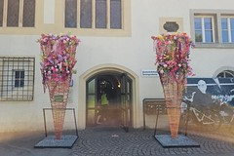 | Landesgartenschau, Ellwangen Mai 2026  An album by christianeduckworth1
   | christianeduckworth1 (Christiane Duckworth) shared their Flickr album with you.

Belgravia in Bloom

My annual pilgrimage was delightful with even more interesting and colourful work. This year’s theme was “out of this world” and featured global tributes to Sir David Attenborough by Ricky Paul from Loughton who lives locally to me - his designs, were situated along the King’s Road. At the nearby Rosebery Gallery were inspirational creative designs by Yan Skates, NAFAS Ambassador.

Belgravia in Bloom coincides with the Chelsea Flower Show – we need these “WOW” moments in our lives!
Karen Davies-James

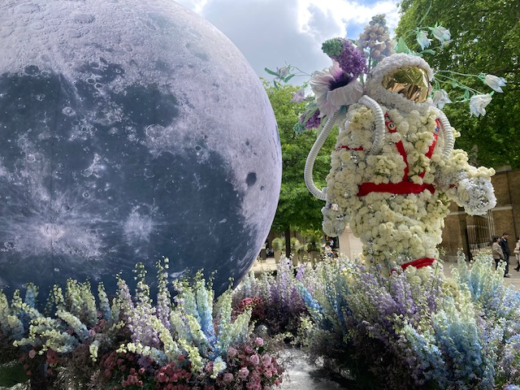 | 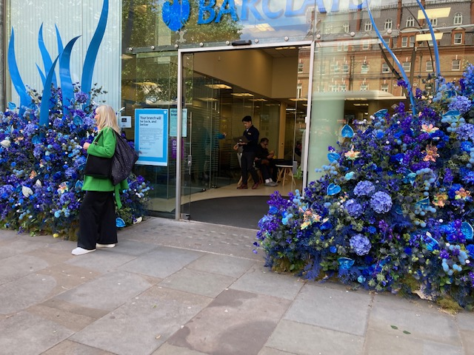

British flowers week ... and Karen's flowers week

Tuesday, I met friends at Beth Chatto Gardens near Colchester Essex, it is hard to recommend a place, but I really enjoyed my visit as I had not been there before. Very educational and they are charting the year's rainfall, see photo, and that was interesting to see. I was with friends who have mobility challenges, one in a scooter, and they were able to wander with me as the place as well as coffee shop and loos was very accommodating.  Although I thought £17 entry fee was quite expensive, no OAP concessions, however you could spend the day strolling there.  I did not manage to visit Garden Museum Lambeth to look at the florist installations as part of British Flowers Week during 17th to 21st June.  Friday 19th June is NAFAS Flower Arranger’s Day, so it is a week full of flowers - how good. | 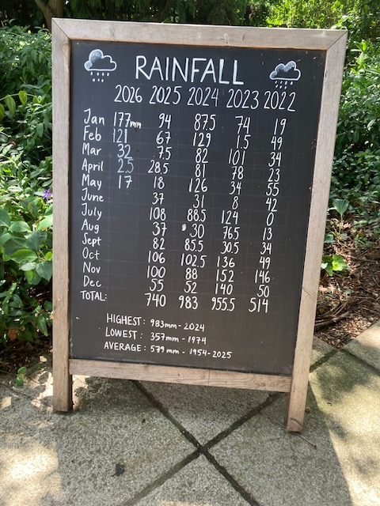

Christine’s Two Minute Tips - May 2026

Lunch in the Park. If you are taking a salad for your lunch in the park but don’t want to carry an ice pack or cool bag, try adding a handful of frozen berries and a handful of frozen nuts just before you go out. By the time you sit down for lunch the berries and nuts will have defrosted, and the salad will still be cool. I find blueberries are the best but keep the lettuce for the sandwich. If you are going to eat late then wrap the box in bubble wrap for extra coolness. If you are taking a sandwich or roll, put it in a zip freezer bag after wrapping it. Leave as much air in the bag as possible and it will act as a cushion, so your sandwich won’t get squashed.

Water. Instead of taking a heavy water bottle to keep your water cold put a lightweight bottle, three quarters full of water, in the freezer overnight and it will gradually melt as you take a sip.

Enjoy your picnic. Your bag will be so light coming home once you have eaten!

Christine Pearce, Ealing FC

NAFAS Agreed Renewal Programme

Following on from the Area meeting in March, chaired by Mig Kimpton (notes of that meeting have been circulated) at the April Council Meeting, Richard Abraham, chief executive of NAFAS, gave those present an insight into the current plans of the Renewal programme put forward by NAFAS to regenerate our clubs.

I felt it my duty (Pat Laughton, Ed) to report that meeting to those who were not present and have tried to reproduce the informative leaflet that Richard handed out for you all to see - but my IT skills are somewhat lacking in such matters, however, here are some highlights from that leaflet that I have reproduced for you all to read.

“The agreed Renewal Programme is designed to increase membership and ensure we reflect the needs and aspirations of our current and potential new members. It is comprised of four interdependent parts, informed by robust market research: namely:

Governance
Working with clubs and Areas, a renewal of governance at a National Area and club level, ensuring structures are sustainable and better- support ongoing activities.

Website
Creation of a new website to better represent us externally and provide password protected access to members.

Database
Creation of a GDPR compliant national database administered by NAFAS Head Office, enabling stronger communication between individual members, clubs, Areas and the national organization.

Brand and Logo
Development of a new brand that both respects the history of NAFAS and is outward facing, to raise public awareness and generate new membership.

These aims will be spread out over the next 3 years:

Year 1 2026-27
Building the infrastructure – a new website with database integration, a new brand and logo, and a new database.
Year 2 2027-28
Testing, implementation and refinement of the core infrastructure developed in year 1.

Year 3 2028-29
Full roll out and move to the new ways of working.”

Richard also covered some of the “hot chestnuts” that have beleaguered clubs for some years, e.g. the payment of the NAFAS subscription that is paid many times over by members who belong to more than one club. That will stop and a one-off fee will be introduced.

I do hope that my “summing-up” of Richard’s address will be of interest and let’s hope his plans for NAFAS are a way forward. Pat Laughton, Ed

And don’t forget……………..

LONDON AND OVERSEAS AREA OF NAFAS

DIGITAL PHOTOGRAPHIC COMPETITION 2026

Seasonal Beauty

This competition is only open to Members of Clubs and
Individual members affiliated to the L&O Area of NAFAS

Class 1 – Spring
A colour image to interpret the title – Spring flowers to dominate, either in a garden or open setting

Class 2 – Summer
A colour image of a floral arrangement with summer flowers being dominant (arrangement does not have to be entrant’s own work)

Class 3 – Autumn
An imaginative manipulated image of a natural landscape showing Autumn colours (original to be included)

Class 4 – Winter
A black and white image showing seasonal beauty

Class 5 – The Beauty of Nature (Novice Class)*
A colour image from any of the above classes, excluding Class 3

*Only for those who have never won a 1st, 2nd, or 3rd in any Area Photographic Competition

NB All elements of every image, particularly in Class 3 – Autumn – must be the work of the entrant – the use of stock images or AI is not permitted

COMPETITORS MAY ENTER UP TO 3 IMAGES IN EACH CLASS
CLOSING DATE FOR ENTRIES: 30th September 2026
All entries will be displayed at the Council Meeting in January 2027

Copyright remains with the entrant of the image

THE JUDGE’S DECISION IS FINAL

All entries, and any queries regarding the competition must be sent by email to Pauline Martindale. Competition Secretary at:
nafaslondonphotos@gmail.com

