FLOWER ARRANGING & MINDFULNESS

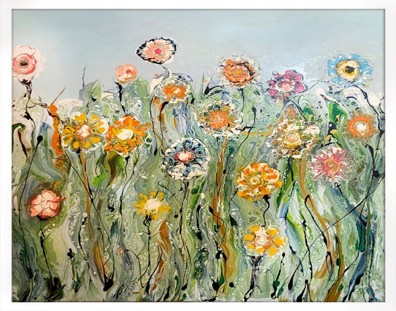

ORPINGTON FLORAL ART SOCIETY
Friendship and Flowers

There are many benefits to joining a local flower club
You do not need to be an artist or a florist
Spending time with flowers can offer real mental health benefits
De-stress, slow down and reconnect with yourself

Where do we meet?
Christ Church Hall, 165, Charterhouse Road, Orpington BR6 9EP
When?
On the second Thursday of the month
Doors open for refreshments at 7.15 pm.

We usually have a demonstration of floral art but sometimes we have a workshop
Arrangements are raffled at the end of the evening

Visitors are always welcome and usually pay £5 but your first visit to a flower club is FREE
More details from Norma Leslie on 020 8467 6213
or by email normaleslie@talktalk.net

