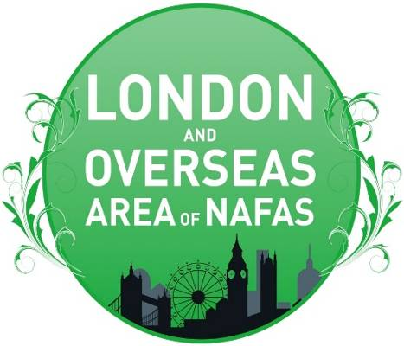 | AREA NEWS  SPRING EDITION 2026  Edited by Pat Laughton  London and Overseas Area of NAFAS  President: Sheila Tasker  Chairman: Peter Bodnar

Chairman’s Message

Spring is my favourite of all seasons displaying natures beauty all around us with my late grandmothers favourite flower starting to open of the magnolia which belongs to the family ‘Magnoliaceae’ which blossoms in March - June.

The petals tend to be more delicate and less resilient than the similar cherry blossom, meaning that they don't stay around for as long. There's no specific place to head for a gathering of magnolia trees, it's more a case of (respectfully) admiring them from outside people's gardens, and in abundance travelling around the UK demonstrating.

Magnolias are an ancient species of flowering plant – fossilized specimens of Magnoliaceae have been dated back to 95 million years ago! Non-native to the UK, these flamboyantly floriferous shrubs and trees are always planted here as an ornamentals, as well as being beautiful and fragrant, the blossoms can be eaten and can have a surprisingly spicy flavour, not unlike ginger.
.
Cut just one stem with secateurs and place in a vase somewhere in your home where they are out of direct sunlight and heat which should last at least a week and change the water every few days.

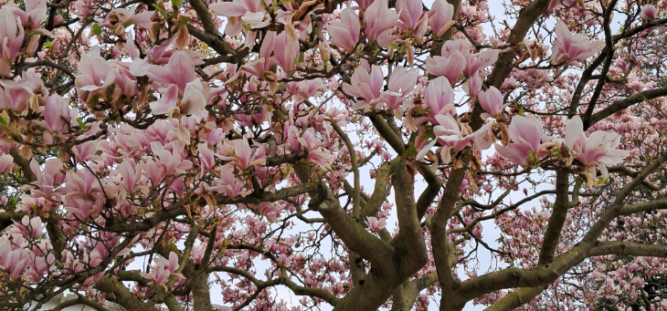

As the areas website is being updated, could I request all clubs submit what exciting events you are offering, whether its a flyer or poster. Please send them direct to me so we can share then with you all at any point in the year.

Area Council Meetings 2026:
Wednesday 29th April – Live meeting venue - Surrey Quays.
Wednesday 29th July – Live meeting venue - TBA
Saturday 24th October – Live meeting – West Wickham.
Club’s round up

Ealing FC

To those that braved the weather for their January club meeting enjoyed Stefan Carolan’s interpretation of a ‘Modern Cathedral’. He told members that anywhere could be classed as a Cathedral where people have gathered together, even Kings Cross Station and our Club Nights with a popular ‘in house’ competition where eight members show casing their exhibits to start the new year with Fun, Friendship, Flowers
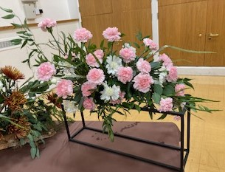
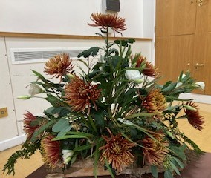
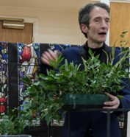

Upcoming Summer Event



Would you like to be involved with this lovely event?
Could you create a display of flowers and artifacts to depict a film you know of?
It could be from Ealing Studios extensive range or any other film that is made in Ealing.
List available if you need inspiration! Or check this link:
https://en.wikipedia.org/Ealing_Studios
Your design can be any colour, shape or size. It can be on a pedestal, table or floor; using any props to support the theme you have chosen. Funds will be available to offset the cost of flowers. If you need any help or advice, please contact: Anne Hamerton (annehamert@aol.com) or Biddy Lall (Biddylall@outlook.com)

Estepona FC

We look forward to welcoming our guest demonstrator, Gill Mills, from North Midlands.
Gill an area demonstrator known for her wonderous use of bright colours, will bring some cheer to our wintery January and in February there will be another Hands-On Fun with Flowers meeting when members will create the basic triangle shaped arrangement.

In March we will be delighted to welcome demonstrator Andrew Key whose demonstration is called “Spring Forward”. Andrew is Chairman of the North Midlands Area of NAFAS and the Chairman of the organisers of the National Show 2027 in Lincolnshire. He is a keen competitor, he won gold at Harrogate, various Best in Show awards and first prize at a recent national Show in Gloucester.

Orpington FAS

Norma Leslie writes - On the 9th April Orpington FAS is holding a workshop making an adaptation of the front cover of the Spring Flower Arranger. If any of your members would like to come and join us, they would be very welcome.

I attach a photo of my mock-up, a first draft, with plenty of scope for alteration. I have used aluminium wire and orchid tubes because of the weight. For the false flowers I have used poppy heads and shiny blue paper. It isn't a 'pot et fleur', just flowers and foliage. We will provide a dish, oasis, aluminium wire, orchid tubes, poppy heads and paper for the petals.  Participants just need sharp scissors as well as floral ones, a pencil and flowers of their choice e.g. freesias or other thin stemmed flowers plus something larger e.g. alstro/roses.  The cost of the evening will be £15 for visitors. If anyone is interested please contact me on normaleslie@talktalk.net or tel 0208 467 6213 | 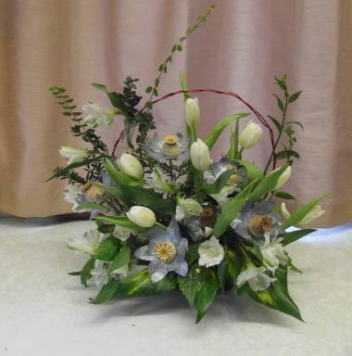

For those of you North of “the river”

A Floral Art extravaganza of flower exhibits and workshops is taking place on 4th and 5th July (preview evening 3rd July) at:

Runnymede Hall, Kiln Road, Thundersley, Benfleet SS7 1TF

Contact Showcase Treasurer Sylvia Kittle at thorpebayflowers@gmail.com

Karen Davies James submitted the following picture of a market stall in Barcelona when she visited before last Xmas. What a super market stall!
In one of the city centre squares the market did not have many food stands.
Instead, there was lots of natural Christmas decorations and foliage. What a surprise. I wish our markets had more like this

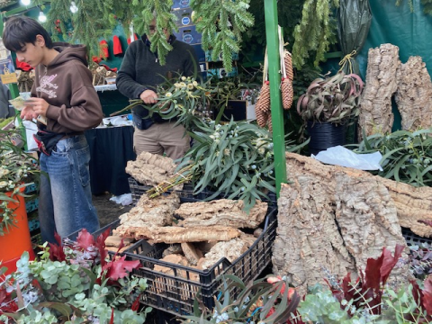

Winter Garden Walk  www.rhs.org.uk/gardens/hyde-hall/articles/winter-garden-at-hyde-hall | 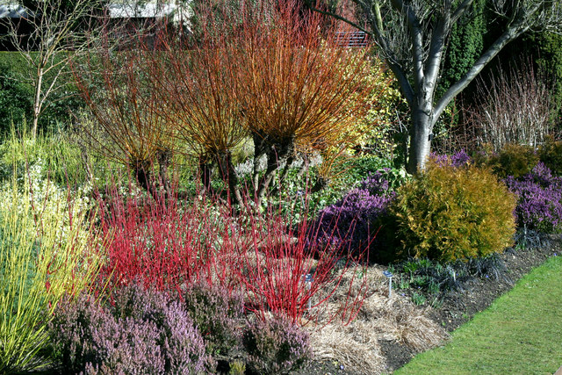

I crossed off an item on my things to do list for January; A lovely experience, a few hours on a guided walk with Amy the gardener curator of the winter walk at RHS Hyde Hall in Chelmsford Essex. We got seriously wet in the pouring rain that day but none of the group minded as it was so interesting and full of surprise. During December to March, the many willows trees and colourful dogwood plants are sculpted and bent into unusual shapes and structures. The woven stems of the bare coppiced willows bring structure to the winter garden, a bit of drama and a display of warmth from the fiery colours. Who would have thought there would be impact and colour in a winter garden - Karen Davies James.

CHRISTINE’S TWO MINUTE TIPS - January 2026

So, you don’t miss any Flower Club Events do put them in your diary now.
That way, when a friend says ‘shall we go out to dinner on a Flower Club
Wednesday’ you can say, ‘shall we go on Thursday? and you can come to Flower Club on the Wednesday?’ That way you have two entertaining evenings.

How about visiting or entering the

NATIONAL FLOWER SHOW
“ANNIE GET YOUR GUN”
15TH TO 17TH May 2026
Hylands House • Chelmsford • CM2 8WQ
Competition Manager:
Mig Kimpton
mig@migkimpton.com 07831 838851

Entry Forms and Details have been sent to your clubs

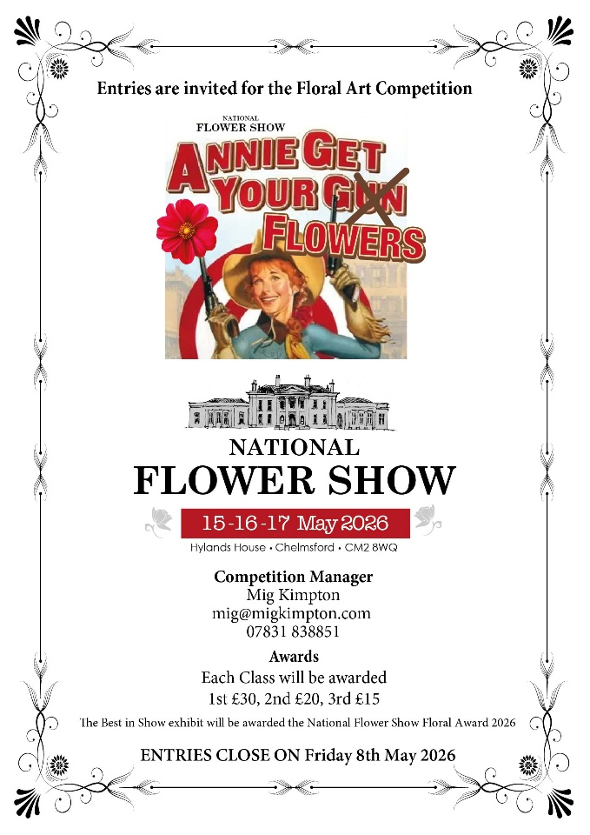

The National Flower Show returns to the stunning grounds of Hylands House in May 2026 for a three-day gardening extravaganza!

It’s the perfect show for gardening enthusiasts and homeowners alike as the ever-growing event celebrates the best of gardening, homes and lifestyle showcasing ideas and inspiration, plus expert plantsmen on hand offering advice and the tools to help create your own garden haven.

Featuring thousands of plants, as well as gardening accessories, floral inspiration, outside furniture, garden ornaments, flower displays, water features, crafts, gifts, food and drink, live music and entertainment, PLUS don’t miss the new Floral Theme inside Hylands House

Early Bird tickets are available online now! Find out more and book your tickets

DIGITAL PHOTOGRAPHIC COMPETITION 2026

Many of you have asked for a copy of the presentation of the winning images of the 2025 Photographic Competition. If you follow this link you should be able to see it and hopefully download it. https://youtu.be/ZZcEzVnlcgY

Entries are now invited for this year’s Photography Exhibition so get “clicking”!

Full details and entry form can be found on the L&O website or by contacting Pauline Martindale: nafaslondonphotos@gmail.com

Competition Theme: Seasonal Beauty

This competition is only open to Members of Clubs and
Individual members affiliated to the L&O Area of NAFAS

Class 1 – Spring

A colour image to interpret the title – Spring flowers to dominate, either in a garden or open setting

Class 2 – Summer

A colour image of a floral arrangement with summer flowers being dominant

(arrangement does not have to be entrant’s own work)

Class 3 – Autumn

An imaginative manipulated image of a natural landscape showing Autumn colours

(original to be included)

Class 4 – Winter

A black and white image showing seasonal beauty

Class 5 – The Beauty of Nature (Novice Class)

A colour image from any of the above classes, excluding Class 3

Multi Discipline Day

We very much hope that you will be able to attend this very informative day with well-known, highly qualified Tutors.

There are so many new floral trends these days so come along – learn and be inspired.

